
Download Image: https://skillgine.com/wp-content/uploads/2026/03/1.jpg

📲 Facebook Post 1 – Copilot vs ChatGPT (Local Business Angle)
Primary text:
Local business owners: there’s a BIG difference between ChatGPT and Microsoft Copilot.
ChatGPT is great for general writing and ideas… but it lives in a public online space and can’t see your business emails, files, or chats.
Microsoft Copilot is built for business.
✅ Works right inside your Microsoft 365 apps (Word, Excel, Outlook, Teams)
✅ Securely uses your emails, files, and chats to give smarter, more relevant answers
✅ Follows your company’s security and privacy rules so your info stays safe and private
ChatGPT doesn’t have access to your business data.
Copilot is private, secure, and designed to help your business work better – not just chat.
👉 Want help setting up Copilot the right way for your local business?
At XXX, we handle readiness checks, secure setup, custom agents, staff training, and ongoing support – so your team can start working smarter right away.
Call to Action (in the post):
📩 Message this page or email XXX to book a free Copilot demo.

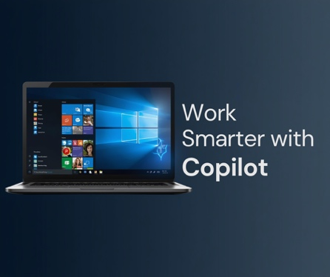

Download Image: https://skillgine.com/wp-content/uploads/2026/04/FB-Hidden-power.png

📲 Facebook Post 2 – “Hidden Power” in Office 365 for Local SMBs
Primary text:
If your local business uses Microsoft 365 – Word, Excel, Outlook, Teams – you’re probably sitting on AI power you’re not using yet.
Microsoft Copilot adds the power of AI right into the Microsoft tools you already use every day. No new software. No new logins.
Copilot can help your team:
🔹 Write emails and replies in seconds
🔹 Summarize meetings so you don’t miss next steps
🔹 Create reports and analyze data quickly
🔹 Stay organized and get more done every day
And your data stays private – inside your Microsoft 365 account, never shared or used to train public AI tools.
Most small and mid‑sized businesses don’t realize how much Copilot can already do for them. We help you unlock that.
Call to Action:
✅ Ready to see what Copilot could do in your local business?
Comment “INFO” below or contact us for a free readiness check and demo.
📧 EMAIL | 📞 XXX

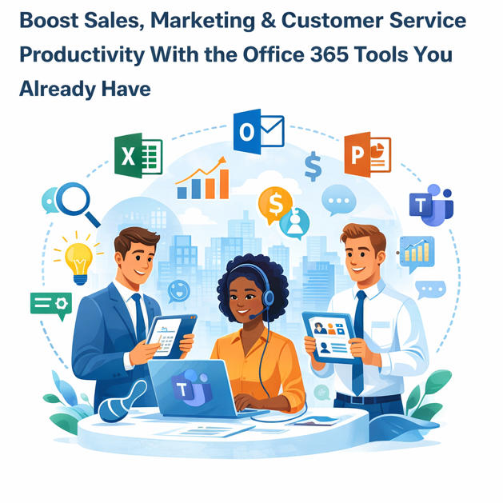

Download Image: https://skillgine.com/wp-content/uploads/2026/04/FB-Hidden-power.png

📲 Facebook Post 3 – Sales, Marketing & Customer Service Productivity
Primary text:
Running a local business means you do sales, marketing, and customer service – often all in the same day.
Microsoft Copilot helps you handle it all, using the tools you already have.
💼 Sales – Close deals faster
• Write follow‑up emails in seconds
• Summarize customer meetings and list next steps
• Create proposals and sales reports automatically
👉 Example: “Copilot, make a proposal for ABC Company based on last week’s meeting.”
📣 Marketing – Create great content quickly
• Write social posts, newsletters, and ad copy
• Review campaigns and suggest improvements
• Build professional PowerPoint presentations fast
👉 Example: “Copilot, write a Facebook post promoting our winter sale in a friendly tone.”
📞 Customer Service – Faster responses, happier clients
• Draft email replies and chat responses automatically
• Summarize past conversations so you know what’s been done
• Create helpful FAQ or training documents easily
👉 Example: “Copilot, summarize this customer’s last three service tickets.”
Call to Action:
Want your existing Microsoft 365 tools to actually drive more sales and better service?
We help local SMBs set up Copilot, build custom agents, and train staff to use it day‑to‑day.
📧 EMAIL | 📞 XXX

